Year  10 |  | Non Right Triangle Trigonometry | Non Calculator
Skills and Knowledge Assessed:  - Apply Pythagoras’ theorem and trigonometry to solving three - dimensional problems in right- angled triangles (ACMMG276)  - Use the unit circle to define trigonometric functions, and graph them with and without the use of digital technologies (ACMMG274)  - Solve simple trigonometric equations (ACMMG275)  - Establish the sine, cosine and area rules for any triangle and solve related problems (ACMMG273) |  |  | Name_________________
Section 1 Short Answer Section
NB THE DIAGRAMS IN THIS TEST ARE NOT DRAWN TO SCALE UNLESS OTHERWISE STATED.
Write all working and answers in the spaces provided on this test paper.

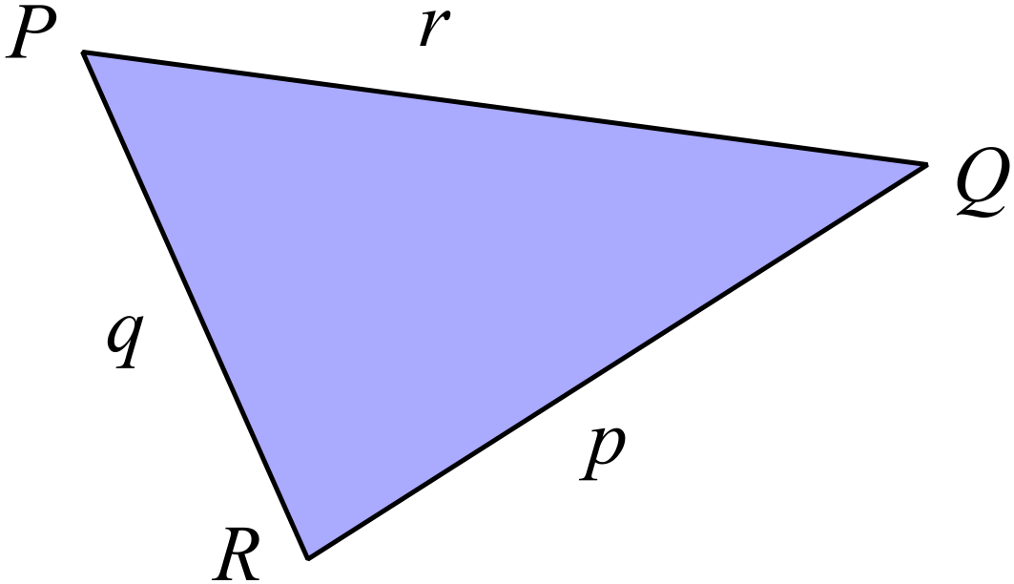Write a statement of the sine rule that could be used to find 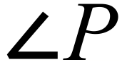 in ∆PQR.
...........................................................................

...........................................................................

...........................................................................

...........................................................................
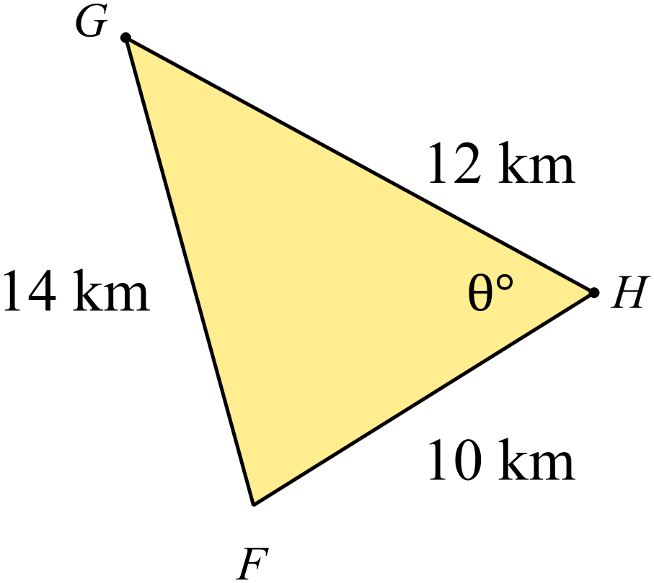Use the cosine rule to find the value of 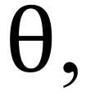 correct to the nearest degree.
……………………………………………

…………………………………………….

……………………………………………

…………………………………………….

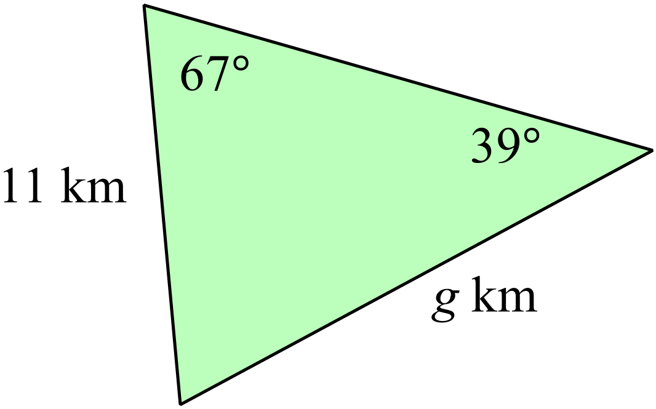Use the sine rule to find the value of 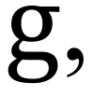 correct to 1 decimal place.
……………………………………………

…………………………………………….

……………………………………………

…………………………………………….

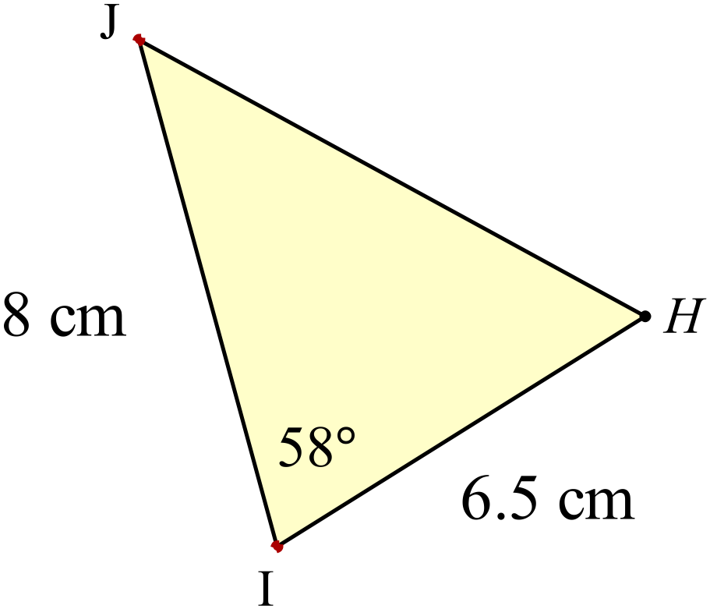Use the area formula to find the area of 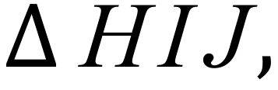 correct to the nearest square cm.
……………………………………………

…………………………………………….

……………………………………………

…………………………………………….

Calculate the value of x correct to one decimal place.

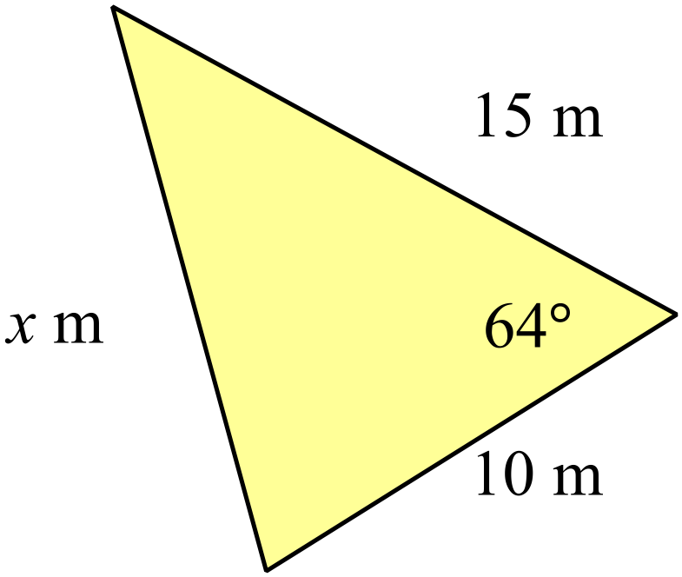
………………………………………………

……………………………………………….

………………………………………………

……………………………………………….

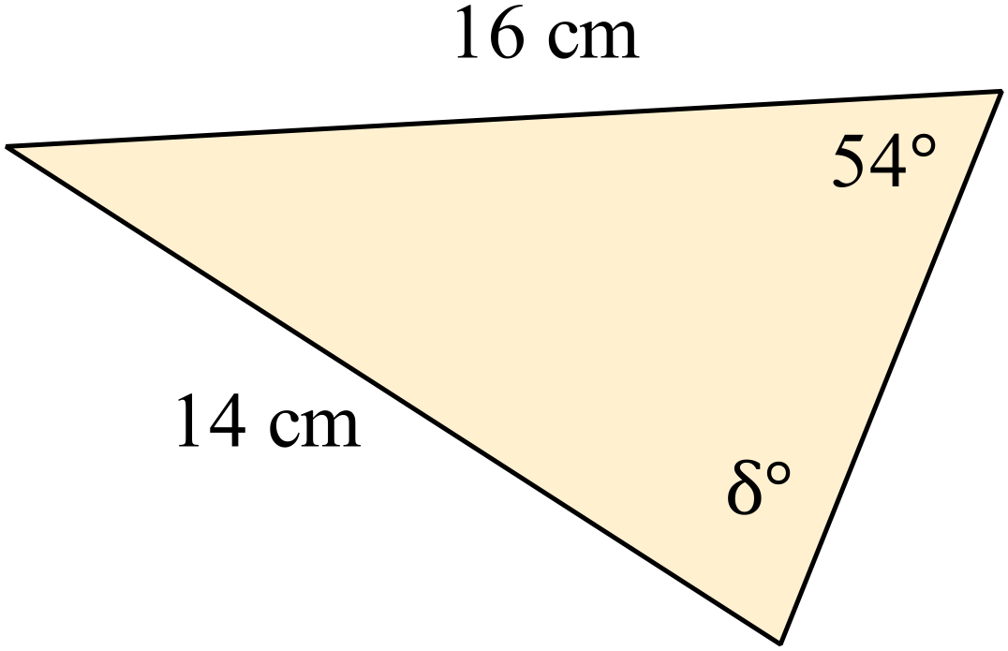Find the value of 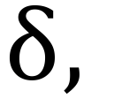 to the nearest degree.

………………………………………………

……………………………………………….

………………………………………………

……………………………………………….
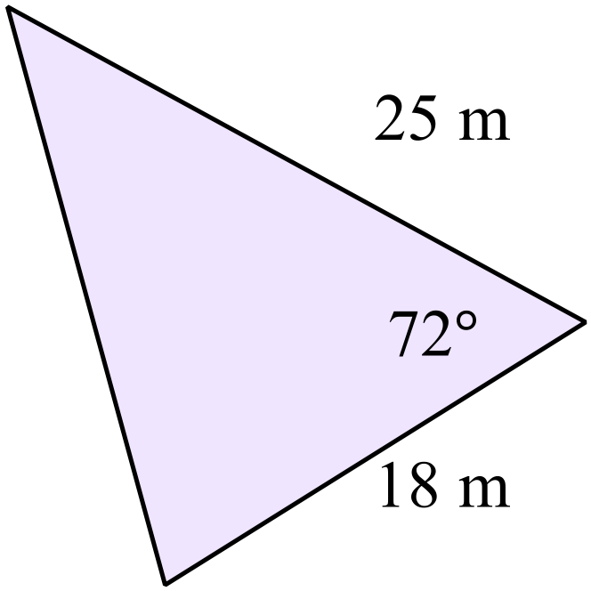Find the area of the triangle shown correct to the nearest square metre.
……………………………………………

…………………………………………….

……………………………………………

…………………………………………….

The distance from ship A to the lighthouse L is 3.8 km and from ship A to ship B is 2.8 km.
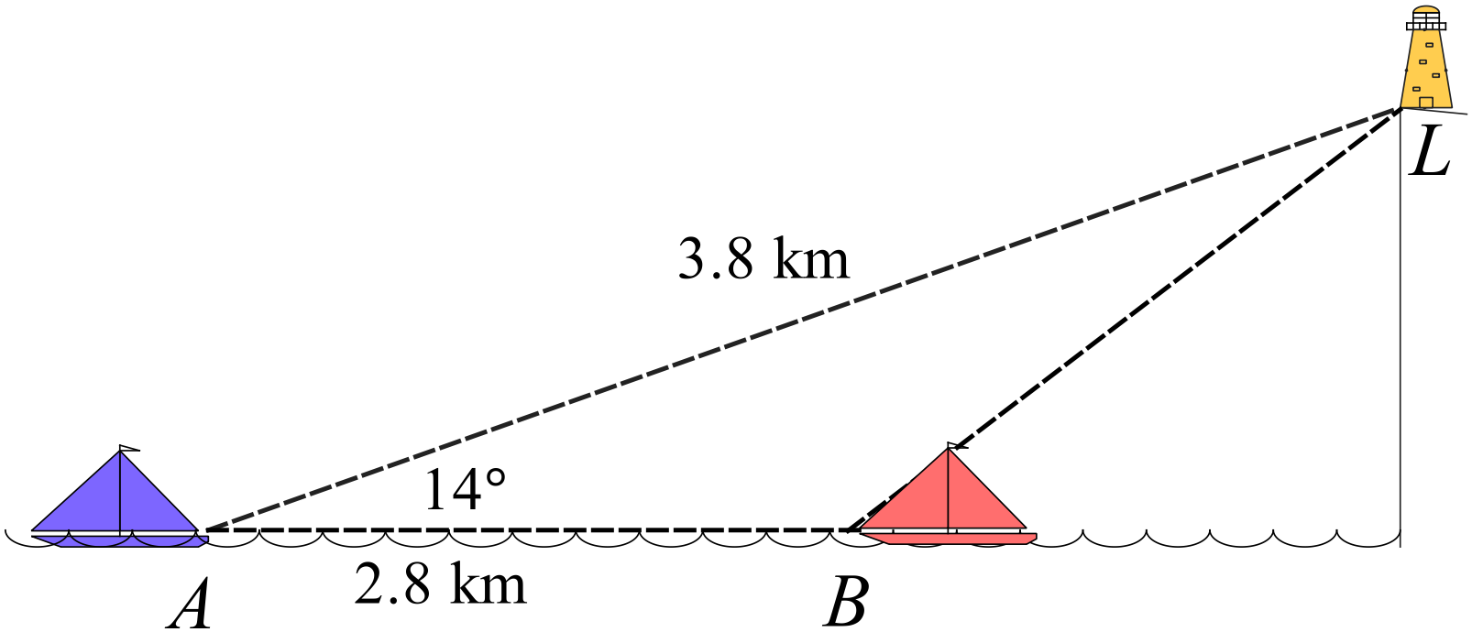The angle of elevation of the lighthouse from A is 14º.
Find the distance from ship B to the lighthouse L correct to the nearest 100 m.
……………………………………………

…………………………………………….

……………………………………………

…………………………………………….
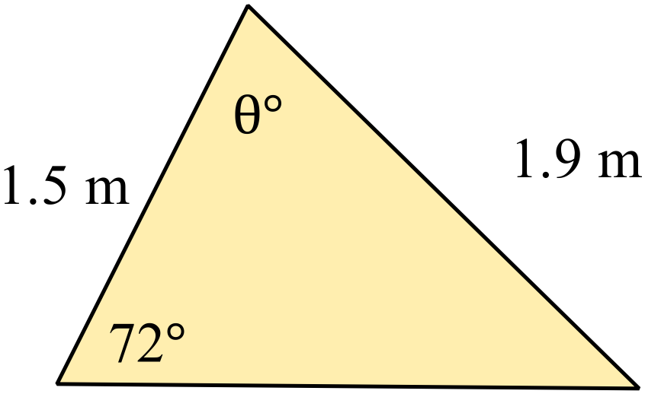Find the value of 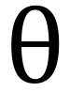 correct to the nearest degree.
……………………………………………

…………………………………………….

……………………………………………

…………………………………………….
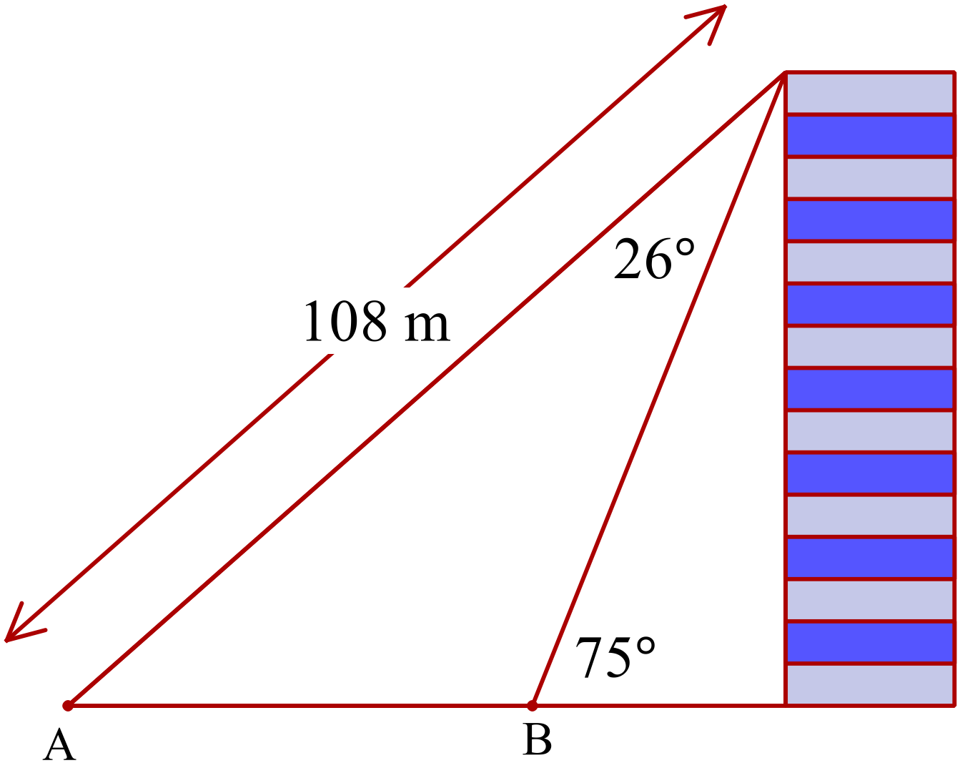Calculate the distance AB, correct to the nearest 10th of a metre.

……………………………………………

…………………………………………….

……………………………………………

…………………………………………….

Use the grid to draw a sketch of 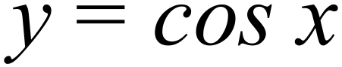 for 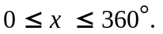
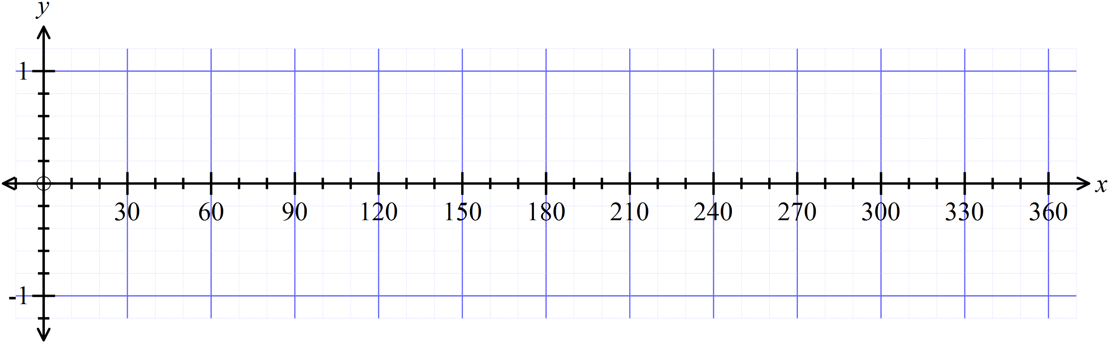

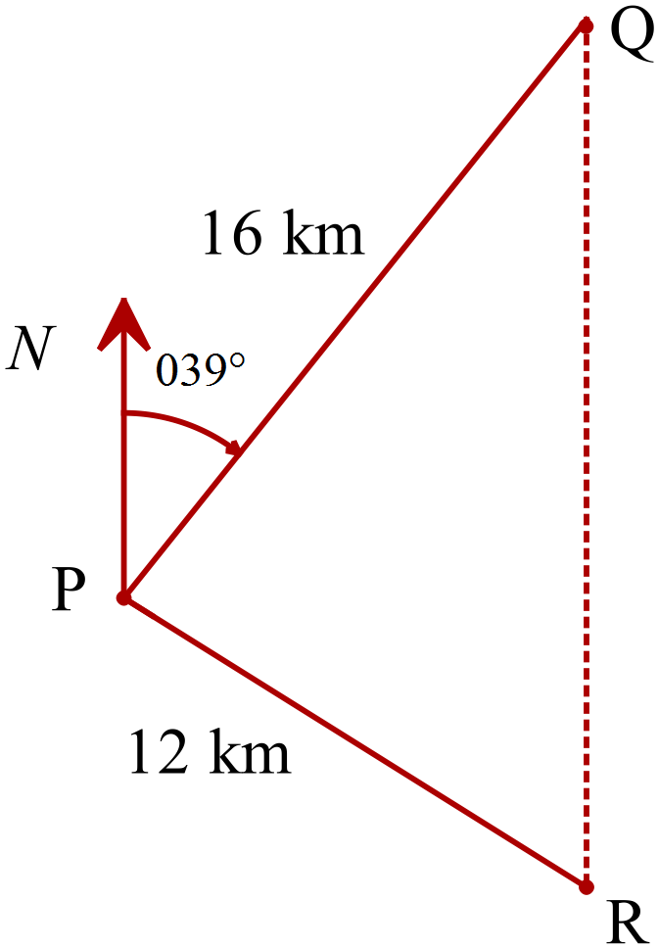Two boats Q and R left port P at the same time and sailed on straight courses. After they had sailed 16 km and 12 km respectively, Q was due north of R.
If Q sailed on a bearing of 039º, what bearing did R sail on?
……………………………………………

…………………………………………….

……………………………………………

…………………………………………….

Year  10 |  | Non Right Triangle Trigonometry | Calculator Allowed
 |  | Non Right Triangle Trigonometry | Name_________________
Section 2 Multiple Choice Section
Mark all your answers on the accompanying multiple choice answer sheet, not on this test paper. You may do any working out on this test paper. Calculators are allowed for this section.

Which equation could be used to find the value of x in 

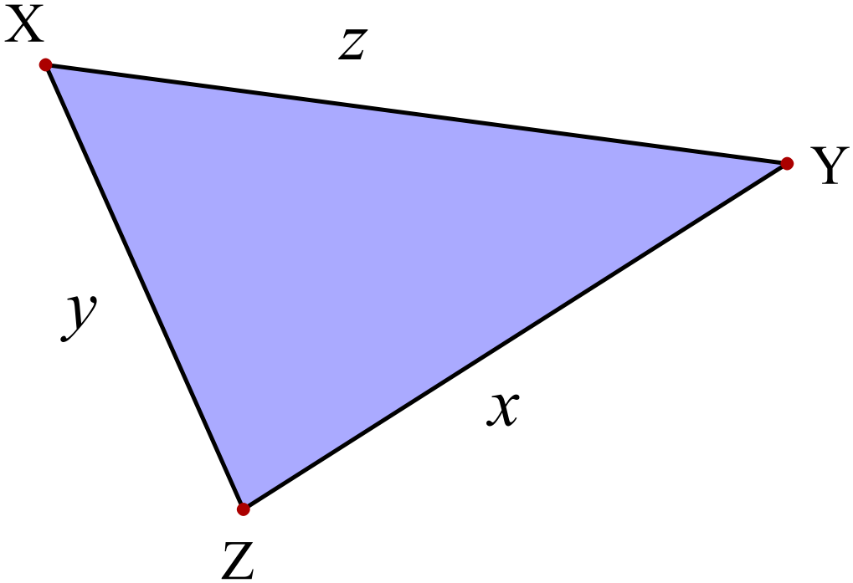

A. 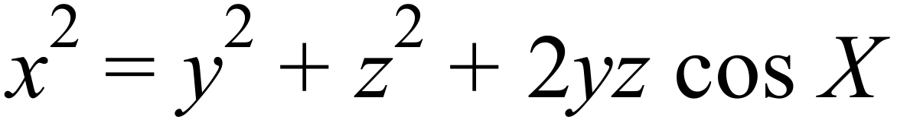

B. 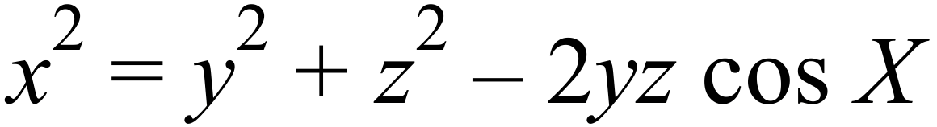

C. 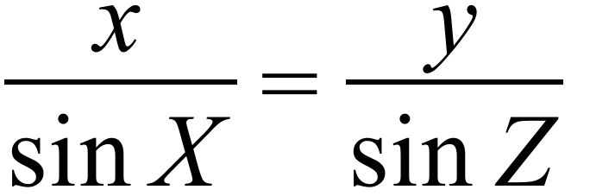

D. 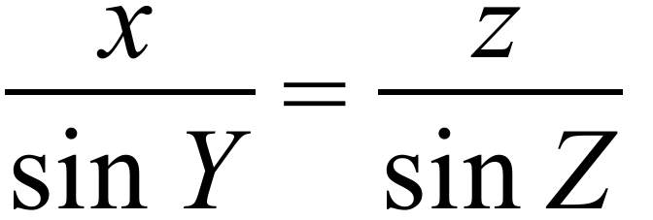

Which is a correct statement for 
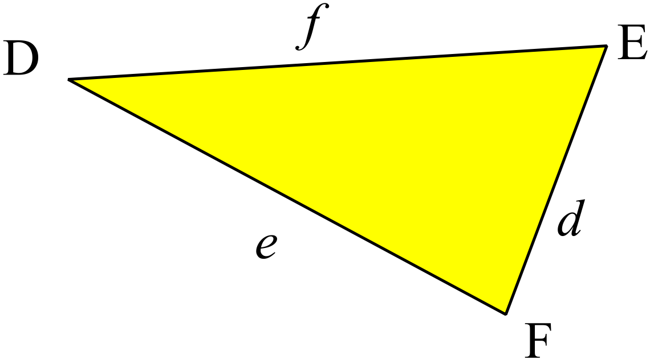
A. 

B. 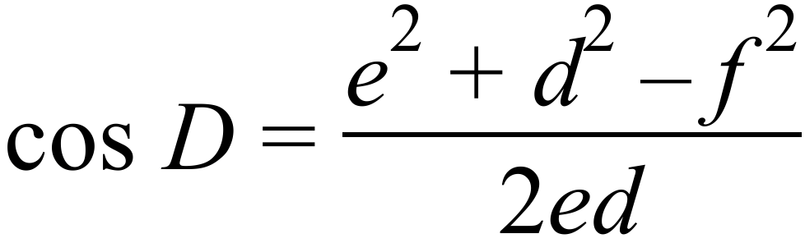

C. 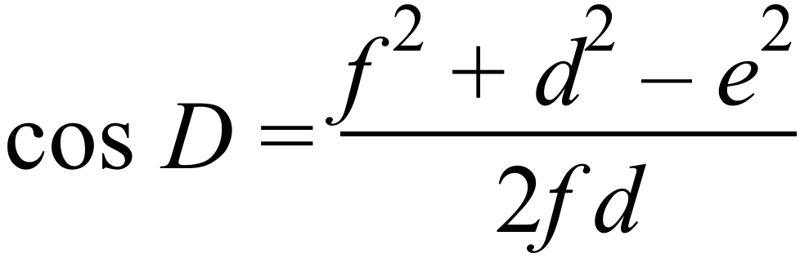

D. 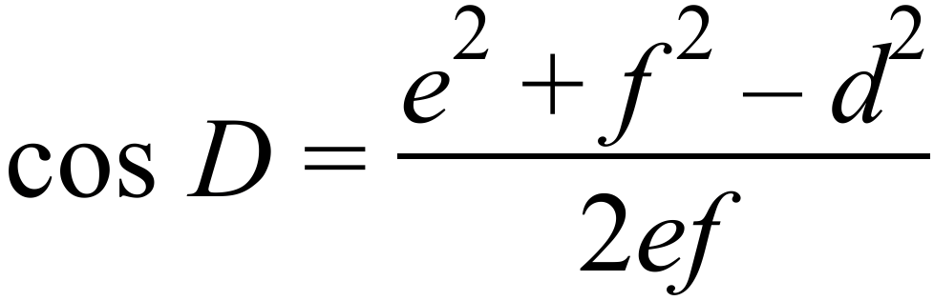

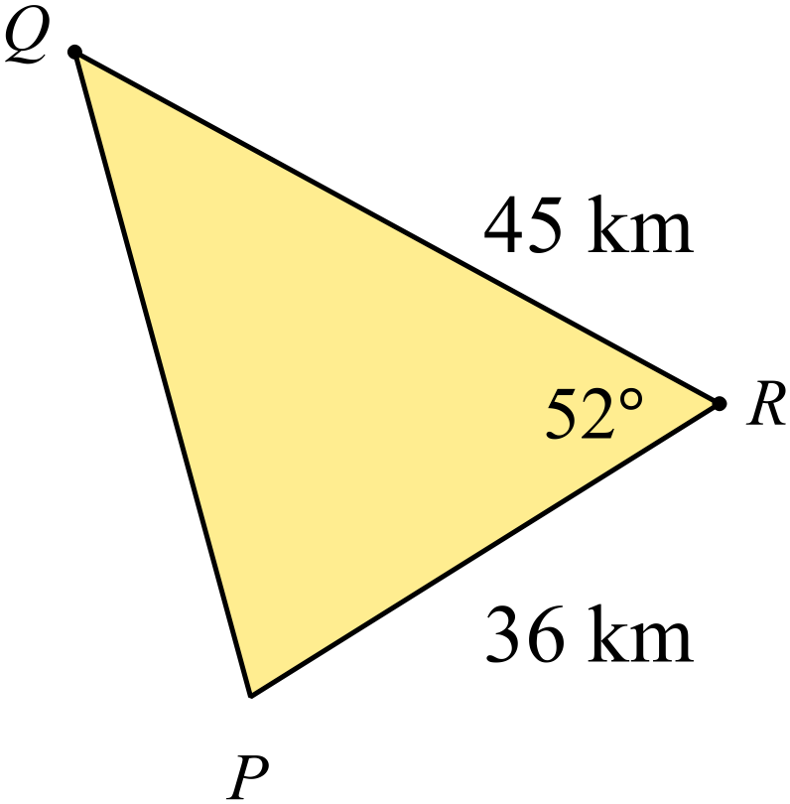Use the cosine rule to find the length of PQ.

A. 36.4 km

B. 57.6 km

C. 72.9 km

D. 1 326.3 km

Use the sine rule to find the size of 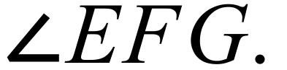 .
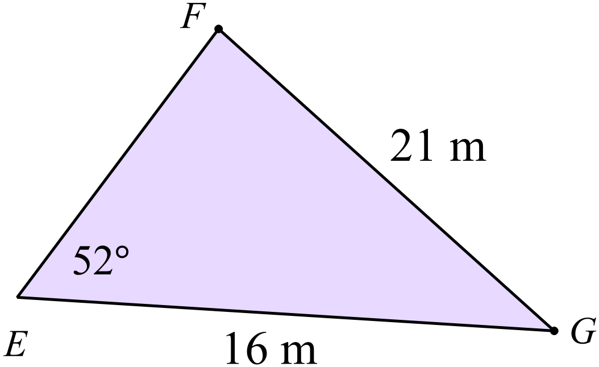

A. 16º

B. 31º

C. 37º

D. 53º

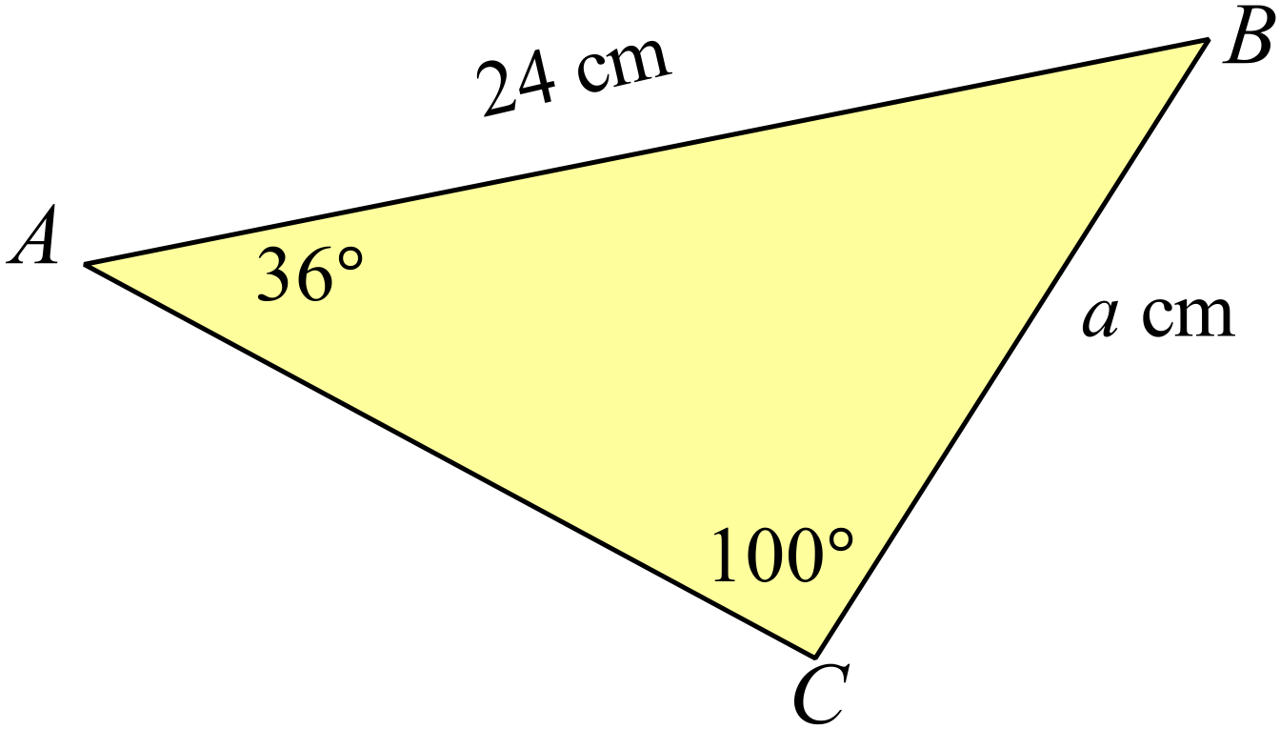Find the value of a.

A. 3.9

B. 14.3

C. 31.1

D. 84.3

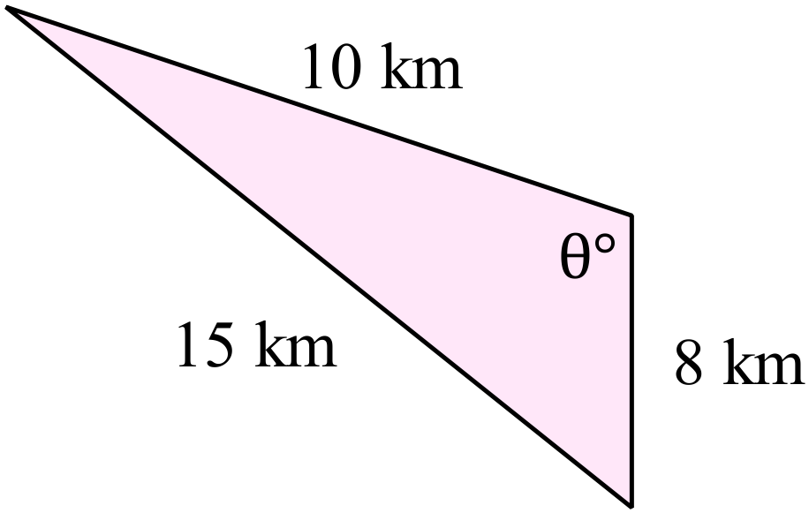 What is the value of 

A. 22º

B. 44º

C. 68º

D. 112º

Find the area of 
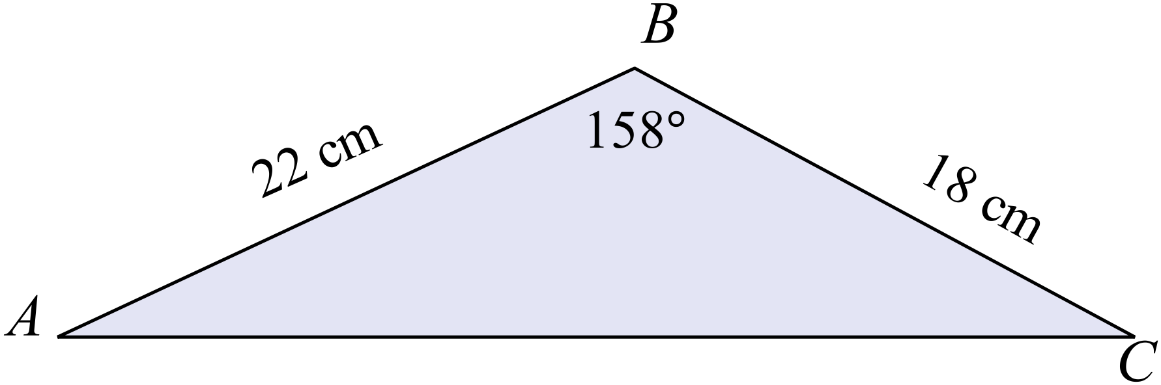

A. 16 cm²

B. 28 cm²

C. 74 cm²

D. 88 cm²

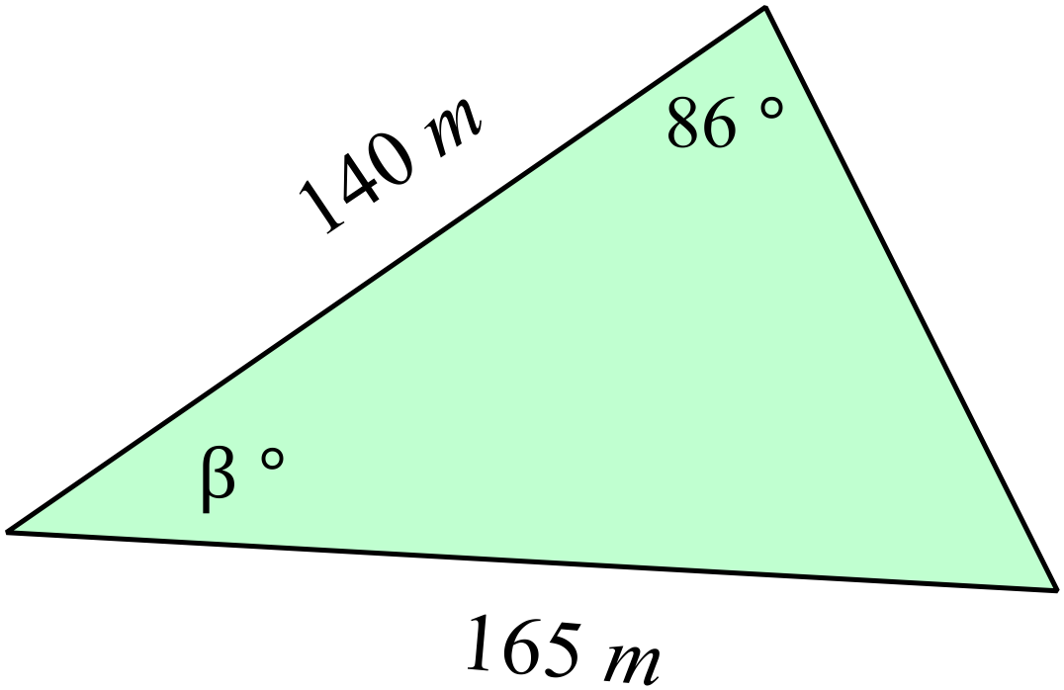Find the value of 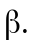

A. 36º

B. 54º

C. 84º

D. 144º

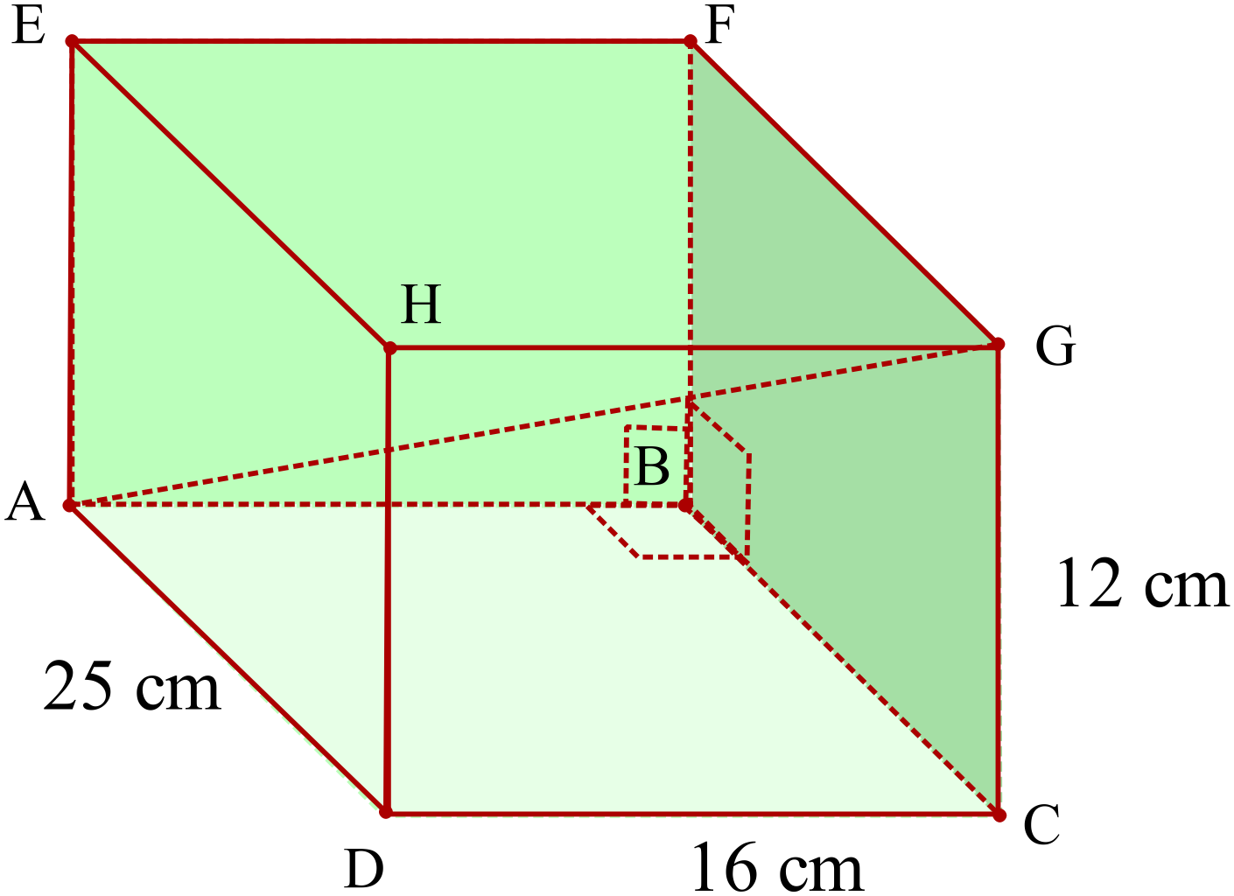What is the length of the interval AG in the rectangular prism shown?

A. 20 cm

B. 30 cm

C. 32 cm

D. 69 cm

Anne and Bertie measure the angle of elevation of the top of a tower (T) to be 20º and 48º respectively.
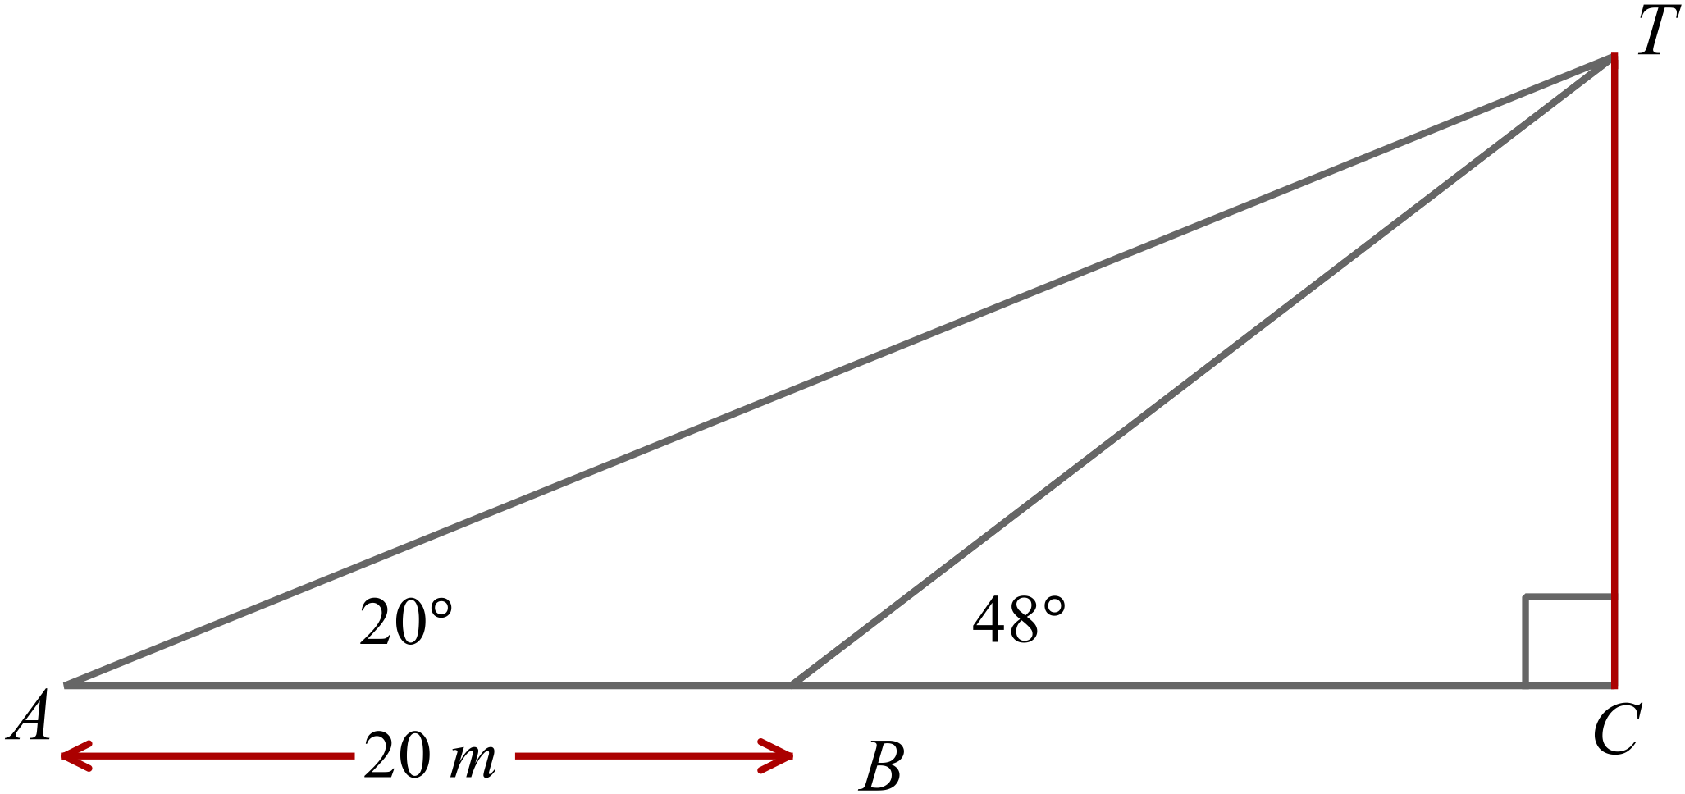
If Anne and Bertie are 20 m apart on a direct line to the tower, calculate the distance BT.

A. 6.8 cm

B. 14.6 cm

C. 22.7 cm

D. 27.5 cm

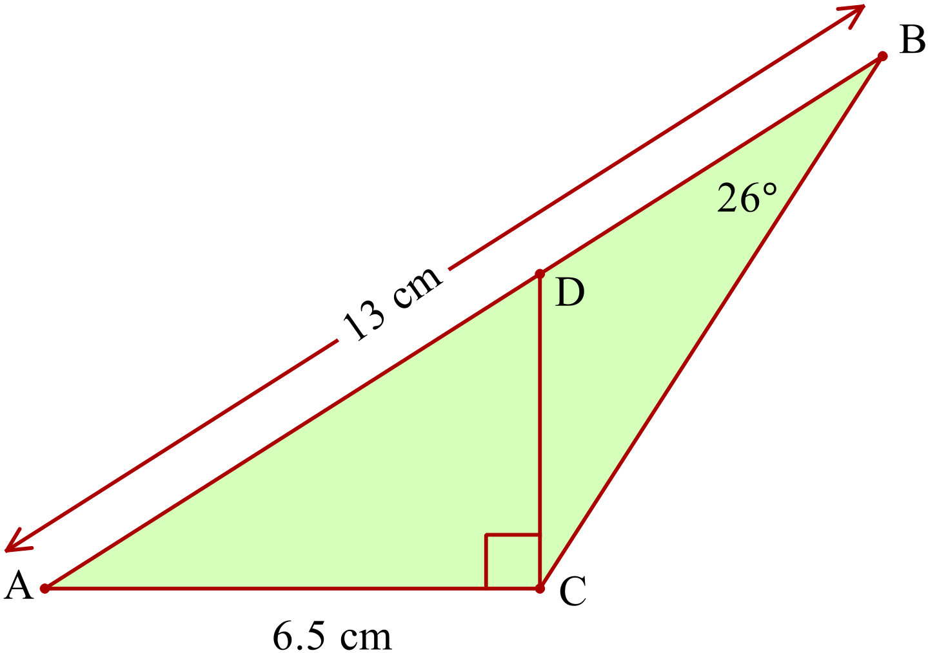Find the size of 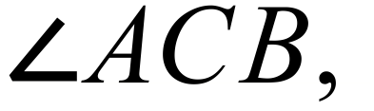 correct to the nearest degree.

A. 29º

B. 45º

C. 61º

D. 119º

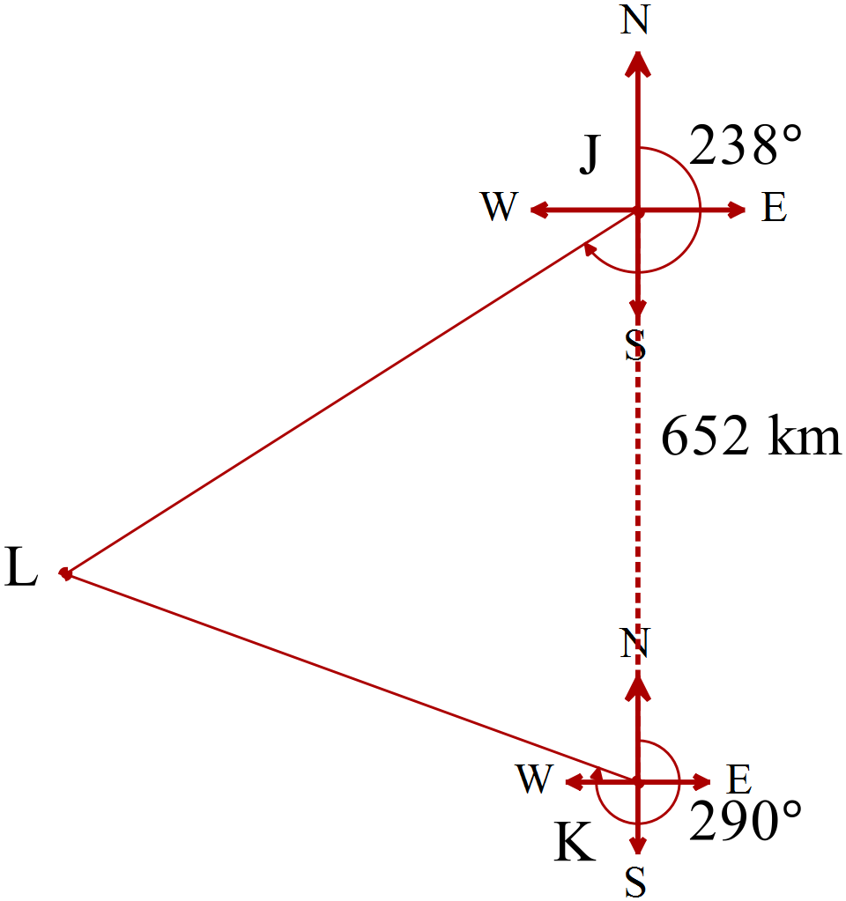A plane L is picked up by two radar stations J and K.

J is 652 km due north of K.

The bearing of L from J is 238º and from K is 290º.

How far is L from K?

A. 702 km

B. 778 km

C. 856 km

D. 958 km

Non Right Triangle Trigonometry

Multiple Choice Answer Sheet
Name _____________________________________________
Completely fill the response oval representing the most correct answer.

1. A B C D
2. A B C D
3. A B C D
4. A B C D
5. A B C D
6. A B C D
7. A B C D
8. A B C D
9. A B C D
10. A B C D
11. A B C D
12. A B C D
13. A B C D
14. A B C D
15. A B C D

Non Right Triangle Trigonometry

ANSWERS
Section 1 ( 1 mark each)
Working and Answers
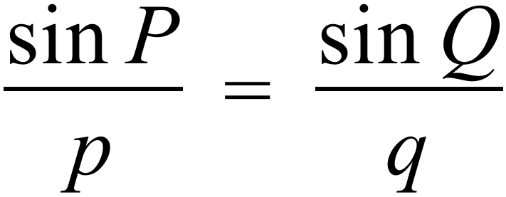 or 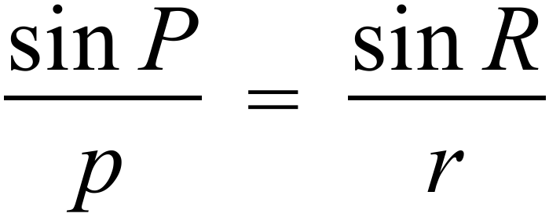
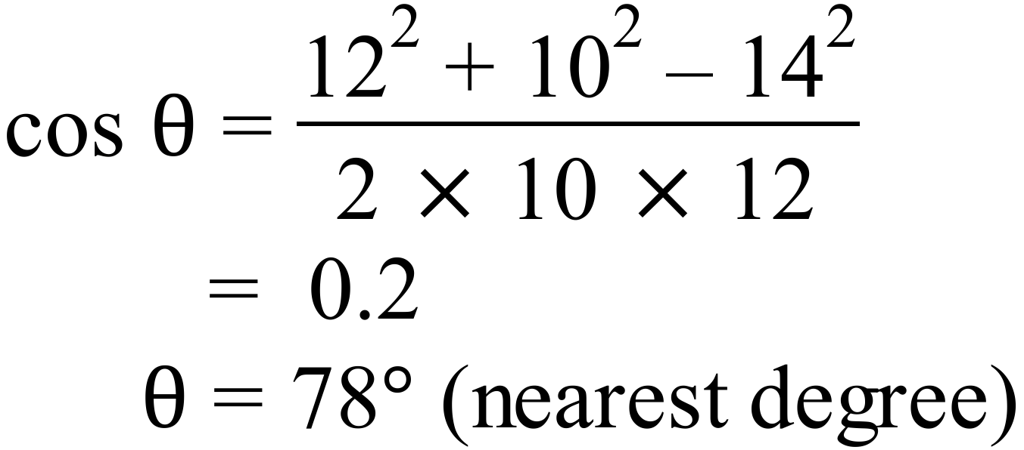
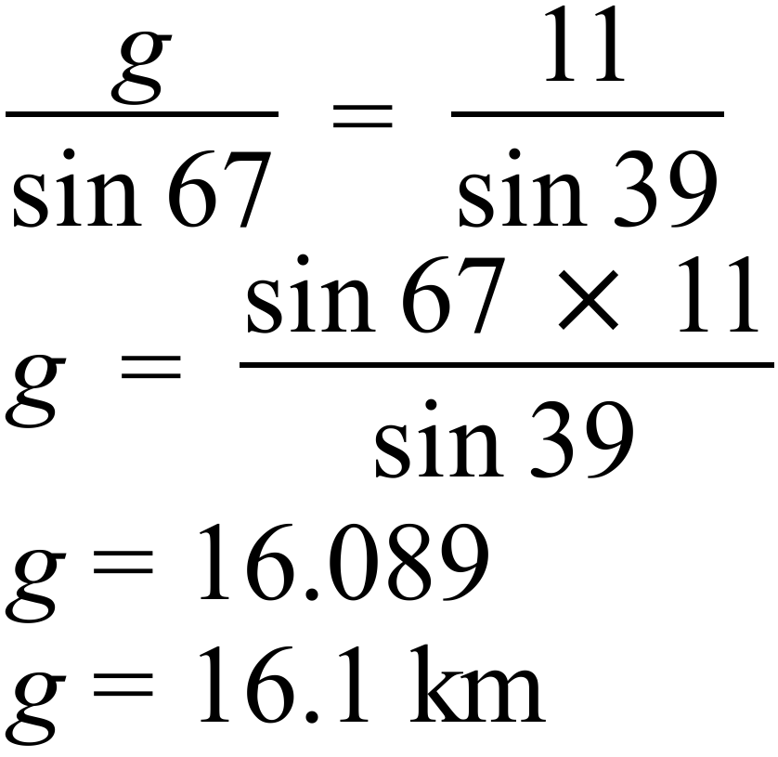
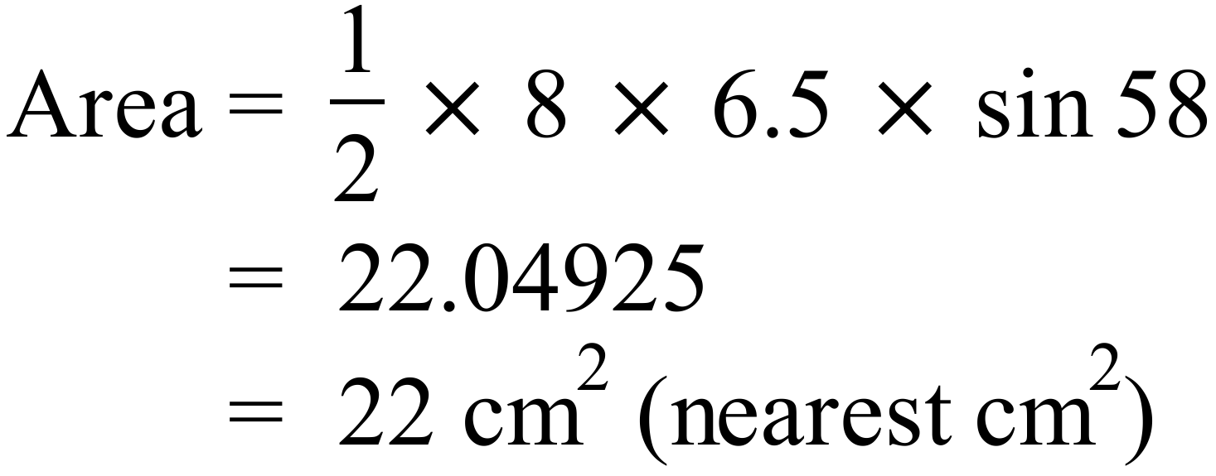
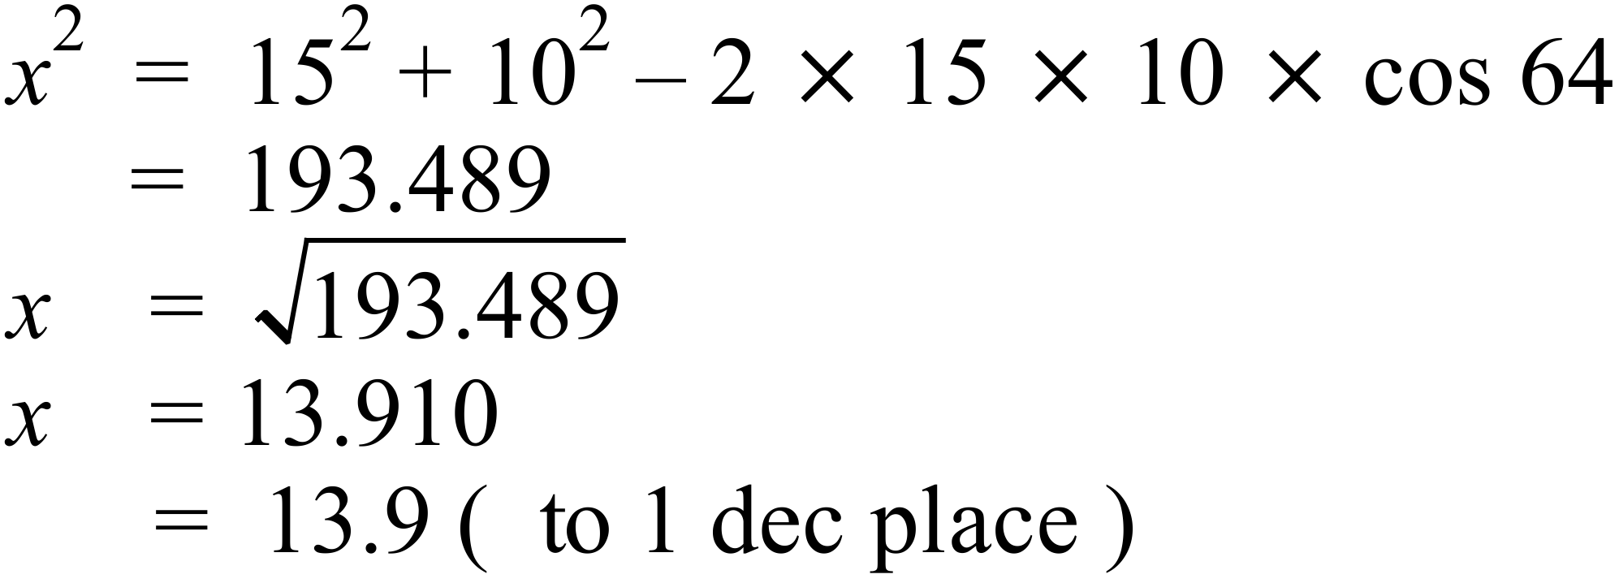
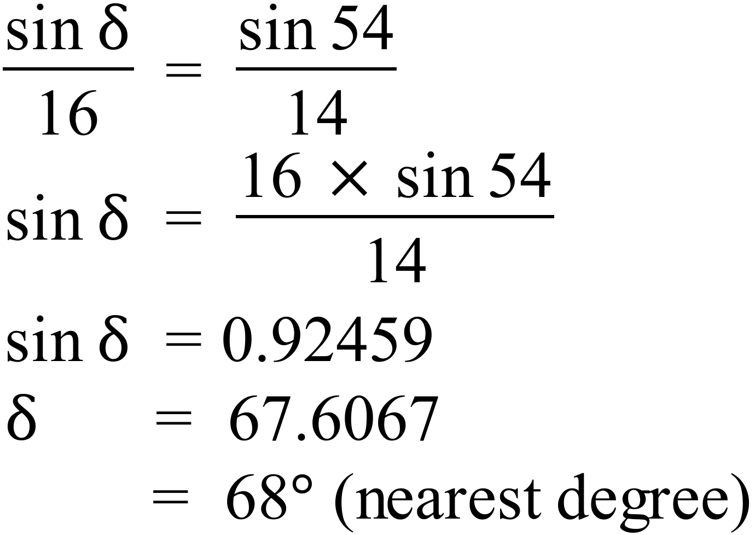
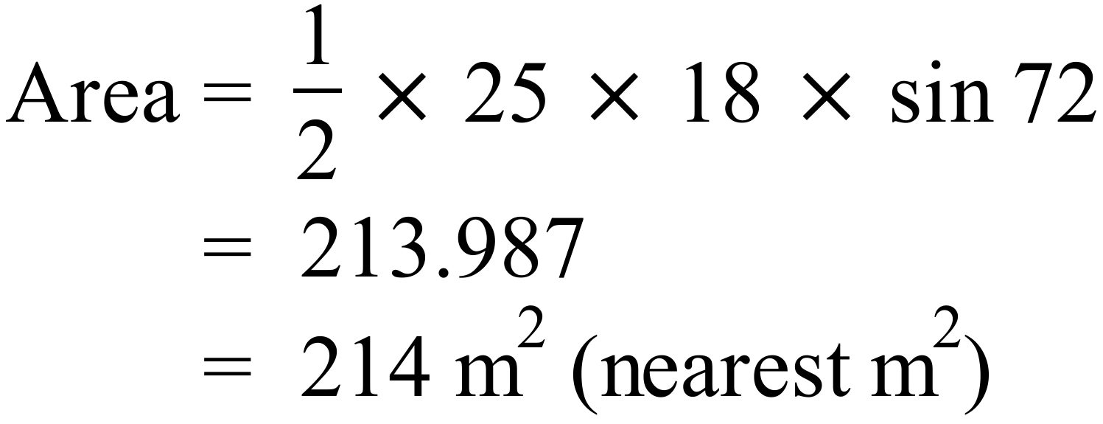
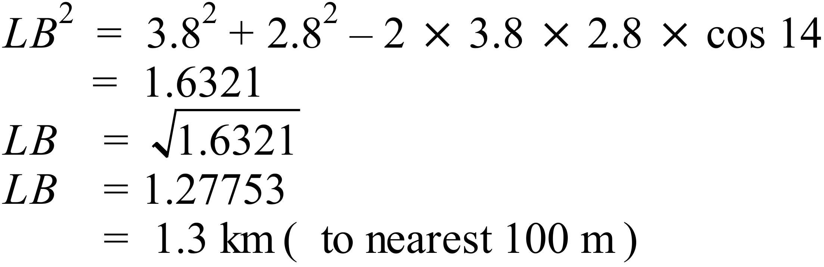
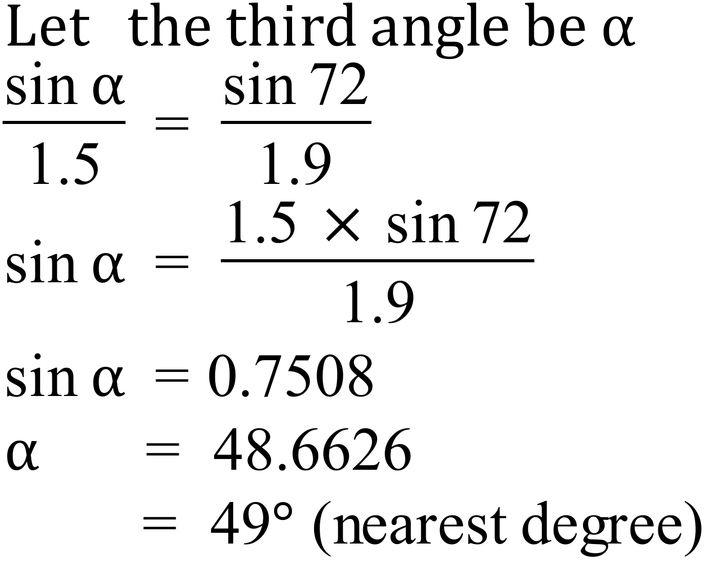
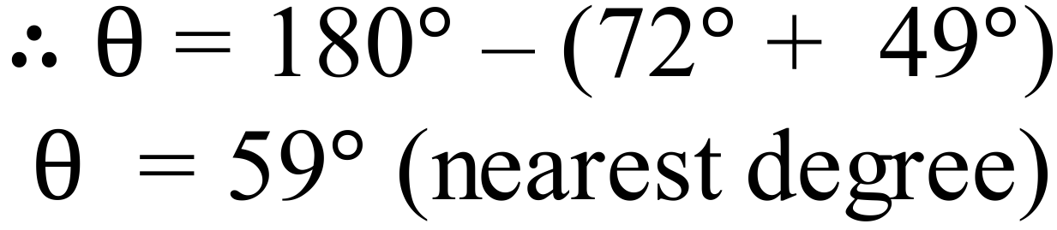
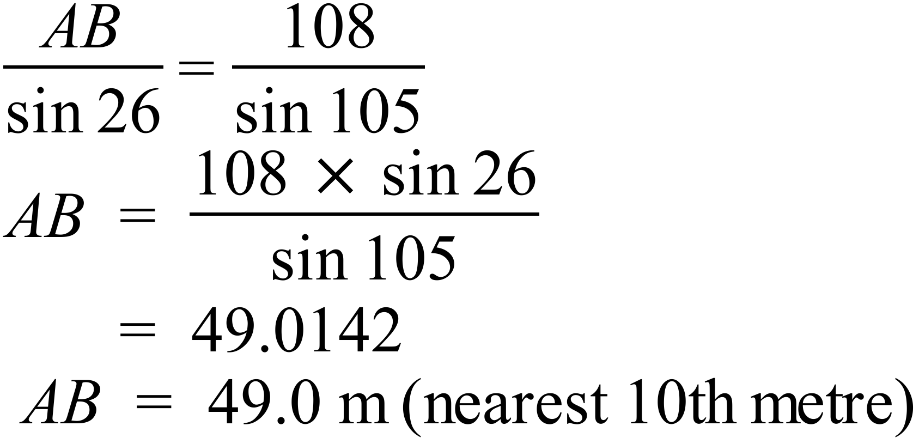
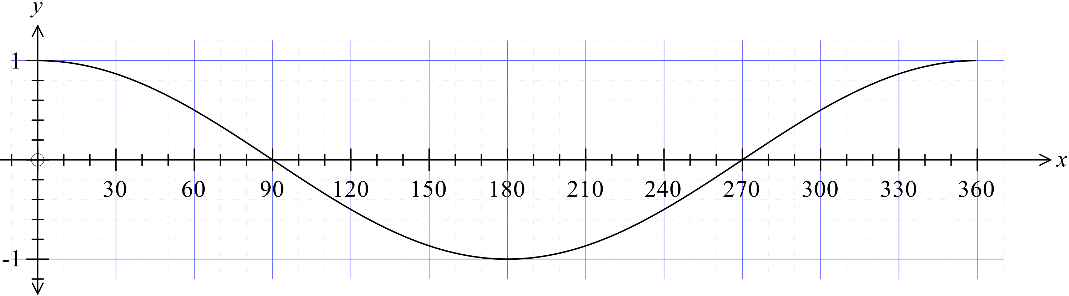

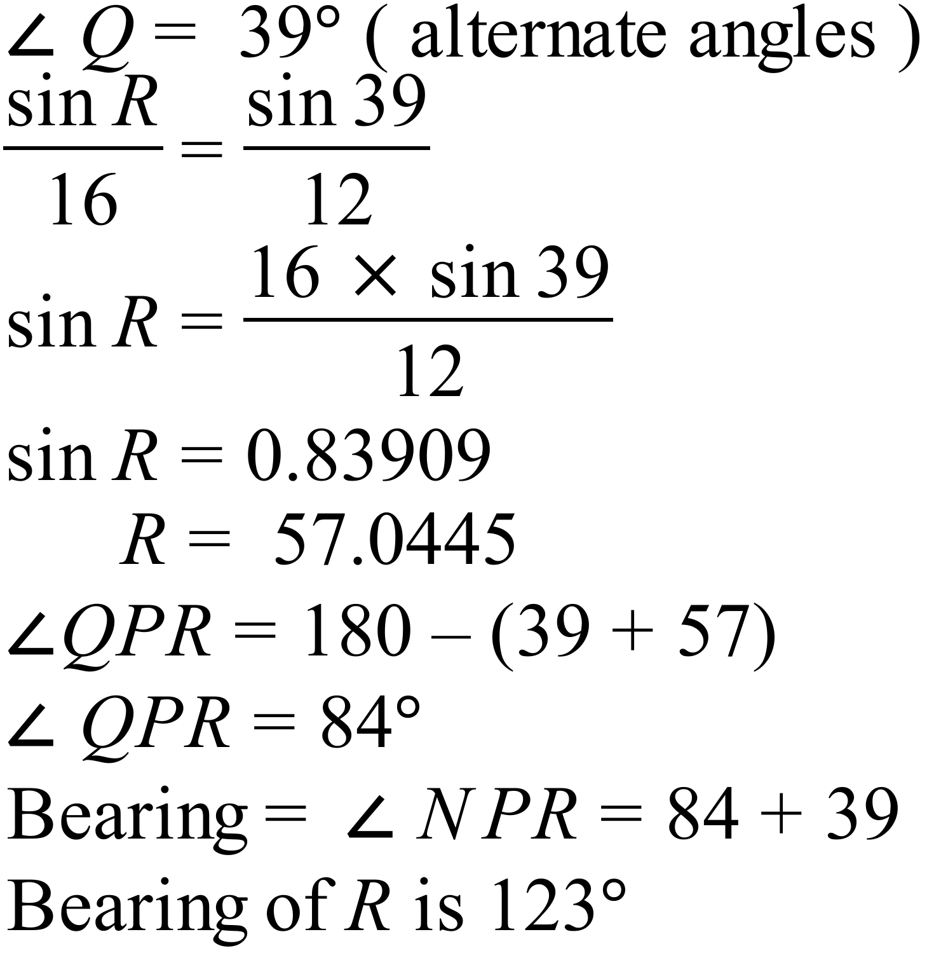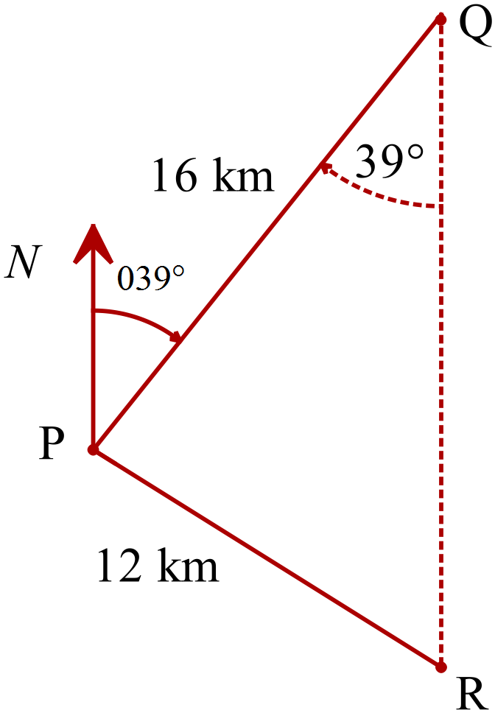

Section 2 (1 mark each)
 | Working | Answers
 |  | B
 |  | D
 | 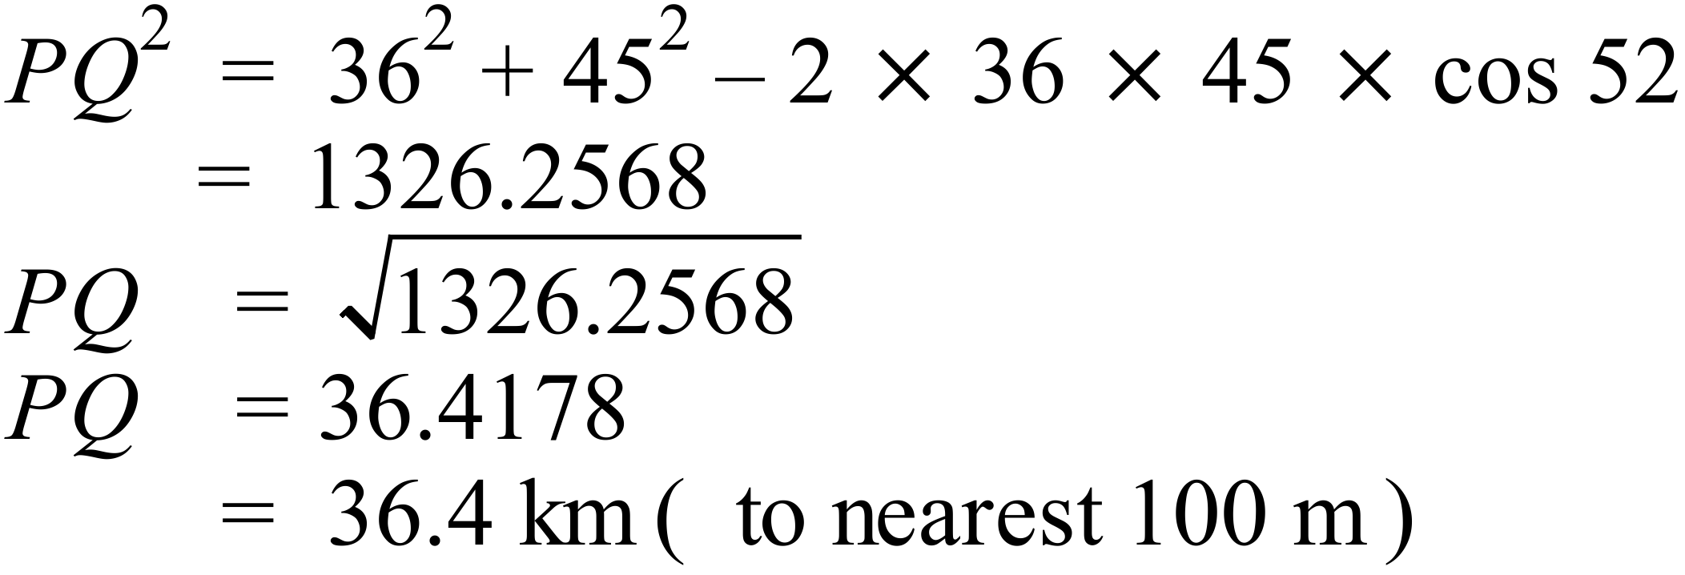 | A
 | 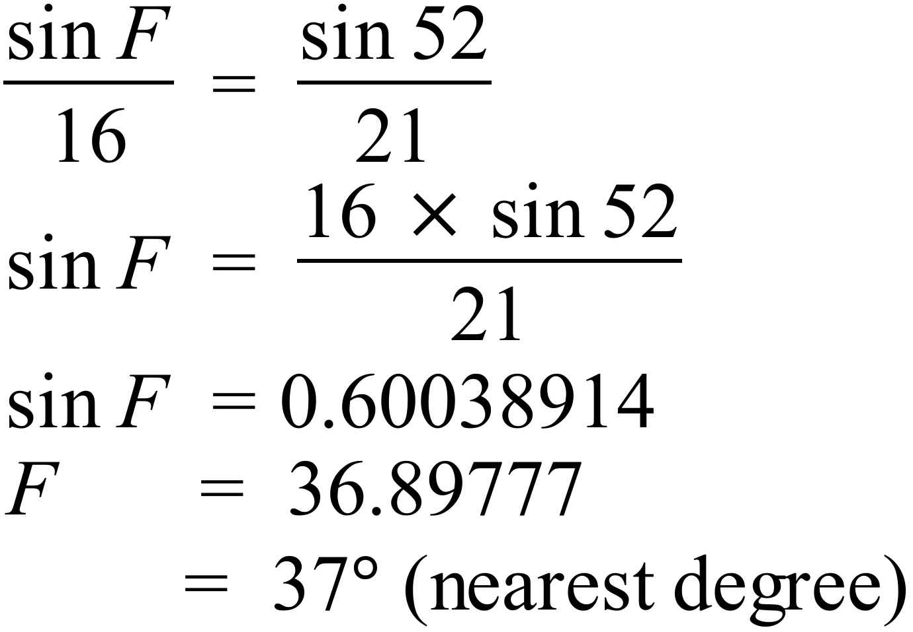 | C
 | 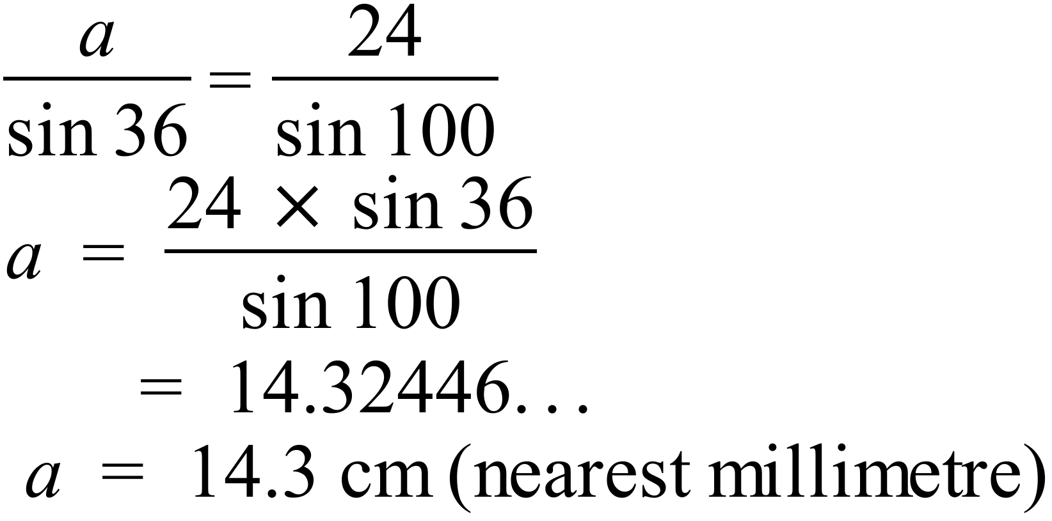 | B
 | 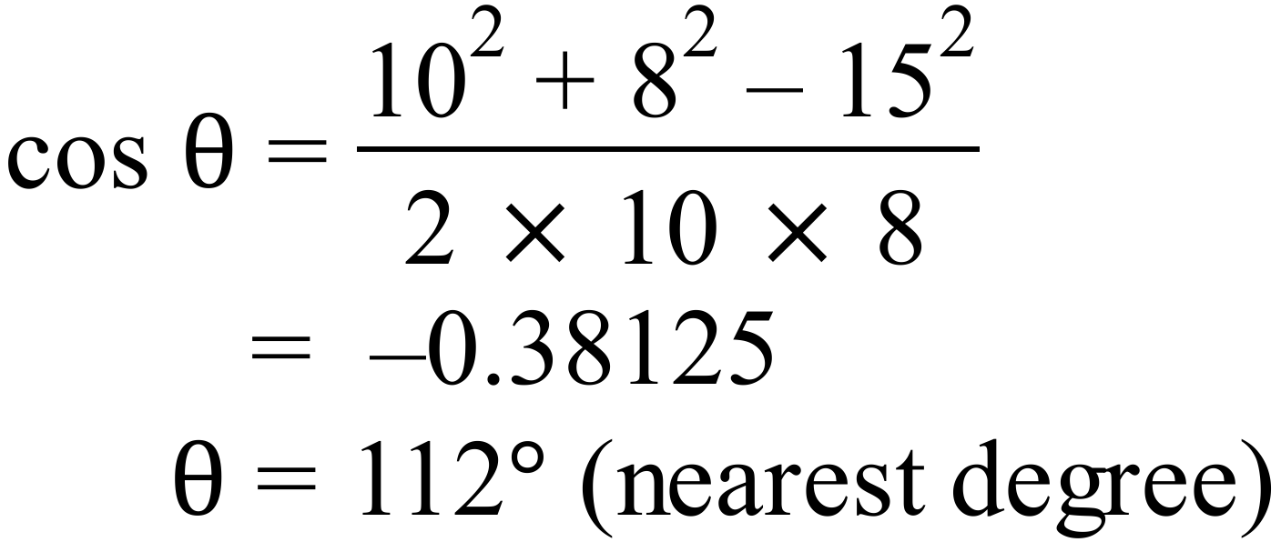 | D
 | 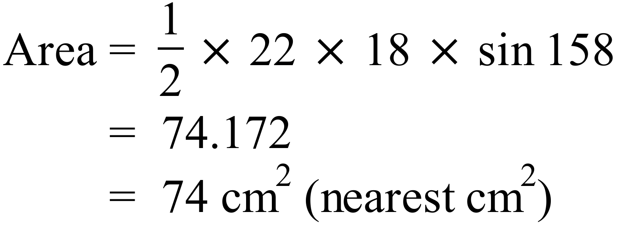 | C
 | 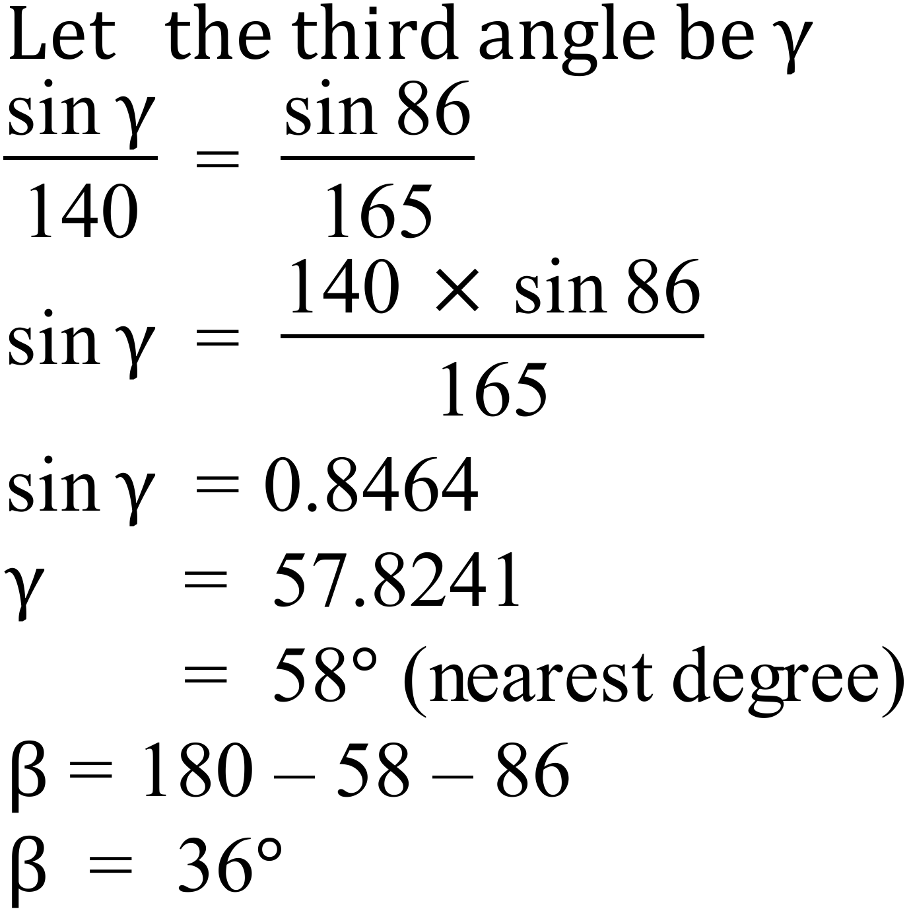 | A
 | 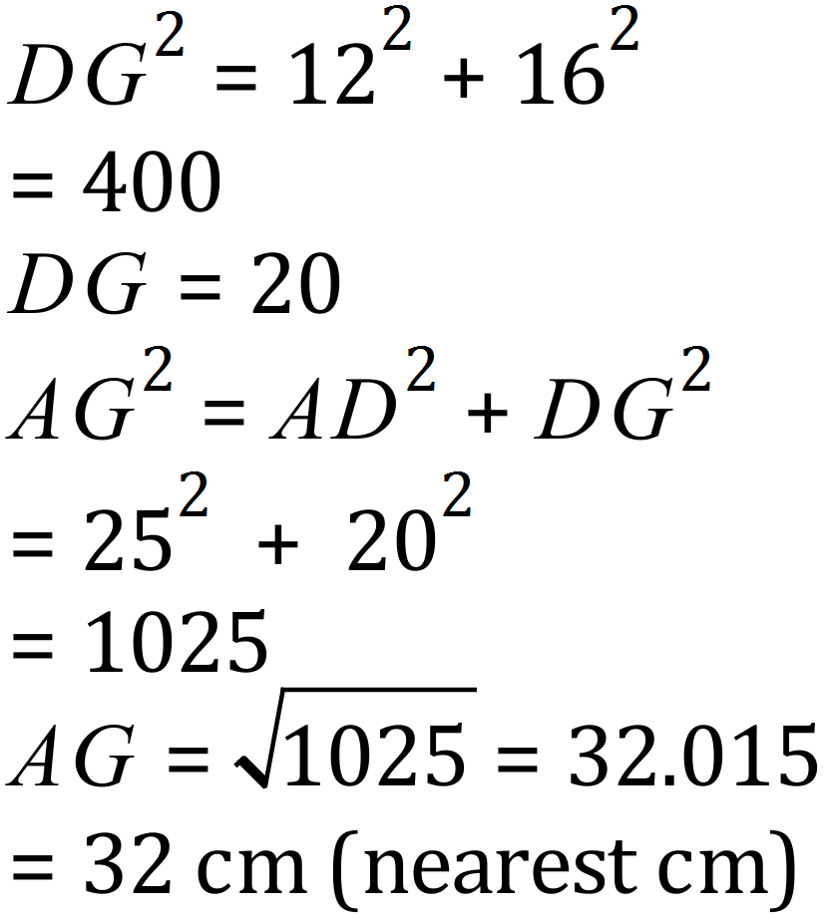 | C
 | 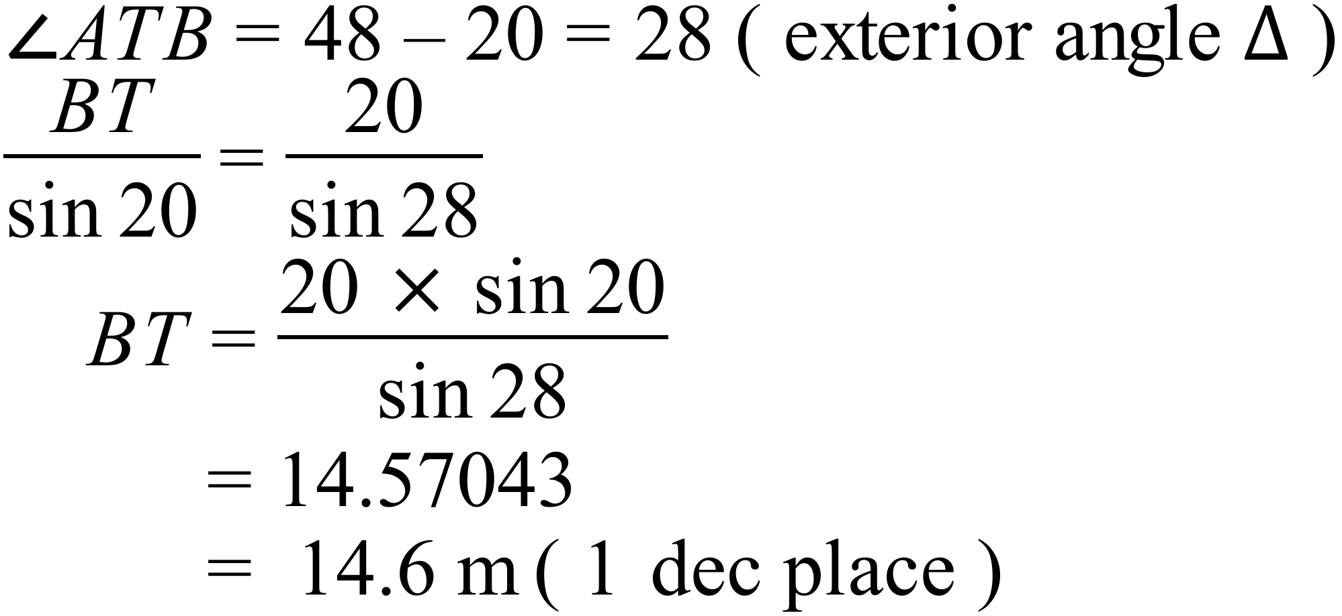 | B
 | 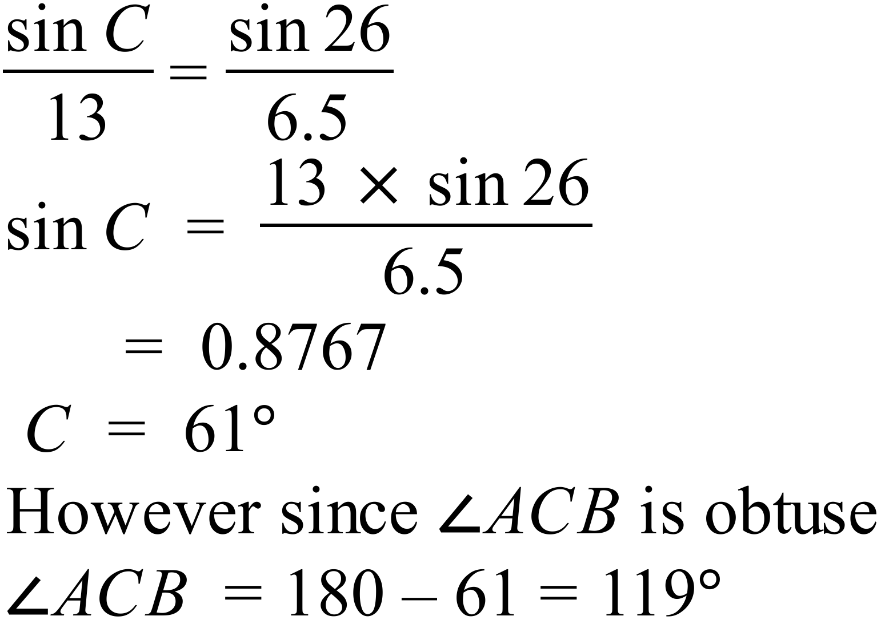 | D
 | 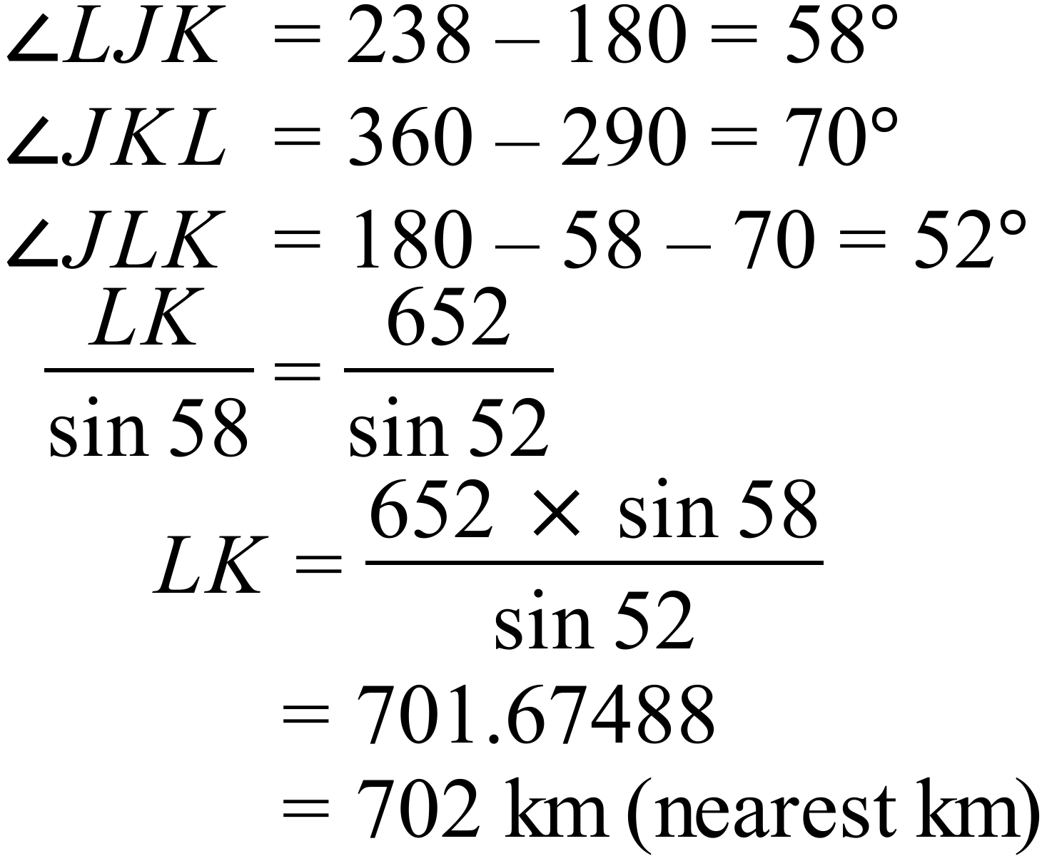 | A

Non Right Triangle Trigonometry

Multiple Choice Answer Sheet
Name ___ Marking Sheet
Completely fill the response oval representing the most correct answer.

1. A B C D
2. A B C D
3. A B C D
4. A B C D
5. A B C D
6. A B C D
7. A B C D
8. A B C D
9. A B C D
10. A B C D
11. A B C D
12. A B C D

